

**AMERICAN INTERNATIONAL UNIVERSITY–BANGLADESH (AIUB)**

**FACULTY OF ARTS AND SOCIAL SCIENCES**

**BUSINESS COMMUNICATION**

Section: **G**

Semester: **Spring 2023-24**

Course Instructor: **THEOTONIUS GOMES**

Report Title: **Addressing Hunger: Analyzing Food Accessibility Challenges and Proposing a Technological Solution for Non-local Students in Dhaka**

**Group Members:**

|  |  |
| --- | --- |
| **Name** | **ID** |
| 1. RUDRO SHINE DATTA | 22-46723-1 |
| 2. MD. ASHIKUZZAMAN ABIR | 22-47006-1 |
| 3. MD. JAHID HASAN | 22-47010-1 |
| 4. A. F. M. RAFIUL HASSAN | 22-47048-1 |

*Submission date: 30thApril, 2024*

**Addressing Hunger: Analyzing Food Accessibility Challenges and Proposing a Technological Solution for Non-Local Students in Dhaka**

**Rudro Shine Datta**

CSE, AIUB  
Dhaka, Bangladesh  
22-46723-1@student.aiub.edu

**A. F. M Rafiul Hassan**

CSE, AIUB  
Dhaka, Bangladesh  
22-47048-1@student.aiub.edu

**MD Jahid Hassan**

CSE, AIUB  
Dhaka, Bangladesh  
22-47010-1@student.aiub.edu

**MD. Ashikuzzaman Abir**

CSE, AIUB  
Dhaka, Bangladesh  
22-47006-1@student.aiub.edu

***Abstract—* Hunger remains a significant challenge, especially for non-local students who face unique food accessibility hurdles. This report investigates these challenges in Dhaka, Bangladesh, through a survey focused on non-local students. We analyze the factors limiting access to affordable, nutritious meals, limited cooking facilities, and busy schedules. This report then proposes a technological solution to address these issues. The study recommends implementing mobile applications or online platforms that connect students with affordable meal options or delivery services.**

***Index Terms*— Food accessibility, Hunger, Non-local students, Dhaka, Technological solution**

# I. INTRODUCTION

## A. Background Information

N

on-local students, those living away from their families while pursuing education, face significant challenges in securing affordable and nutritious meals. This is particularly true in Dhaka, Bangladesh, where a confluence of factors contributes to student hunger. Limited budgets, lack of cooking facilities, unfamiliarity with the city, and insufficient time for meal preparation all contribute to this issue. Additionally, students with dietary restrictions may find their options even more limited.

***B. Overview***

This report investigates the issue of food accessibility for non-local students in Dhaka. We explore the challenges students face and propose potential solutions to ensure they have access to affordable and nutritious meals. Our goal is to contribute to a more food-secure environment for students, maintaining their academic success and well-being.

# II. METHODS

## A. Description of the Solution

This study proposes a multi-pronged approach to address food insecurity among non-local students in Dhaka. The proposed solutions aim to:

* **Increase access to affordable and healthy meals:** Explore partnerships with universities to establish subsidized canteens or collaborate with local restaurants to offer student discounts.
* **Promote awareness and education:** Spread out information about existing food banks, community kitchens, or student-run initiatives that provide meals or groceries.
* **Develop essential food preparation skills:** Organize workshops that equip students with basic cooking skills and budget-friendly recipes, empowering them to prepare healthy meals within their limited resources.
* **Facilitate convenient and affordable options:** Investigate the feasibility of mobile food vendors offering healthy and affordable meals near student residence.

## B. Methods Used

To gain a deeper understanding of the issue, the following methods would be employed:

* **Student Surveys:** Conduct surveys or interviews with non-local students to gather data on their experiences with food accessibility. This would include information on their budget constraints, dietary needs, and current food sources.
* **Food Vendor Analysis:** Analyze the availability, affordability, and nutritional value of food options around universities and colleges in Dhaka. This would involve identifying existing vendors, assessing their pricing structures, and evaluating the nutritional content of their offerings.
* **Review of Existing Initiatives:** Research existing programs that address student hunger, such as subsidized canteens or meal voucher programs implemented by universities or NGOs.

# III. RESULTS AND DISCUSSIONS

***A. Results***

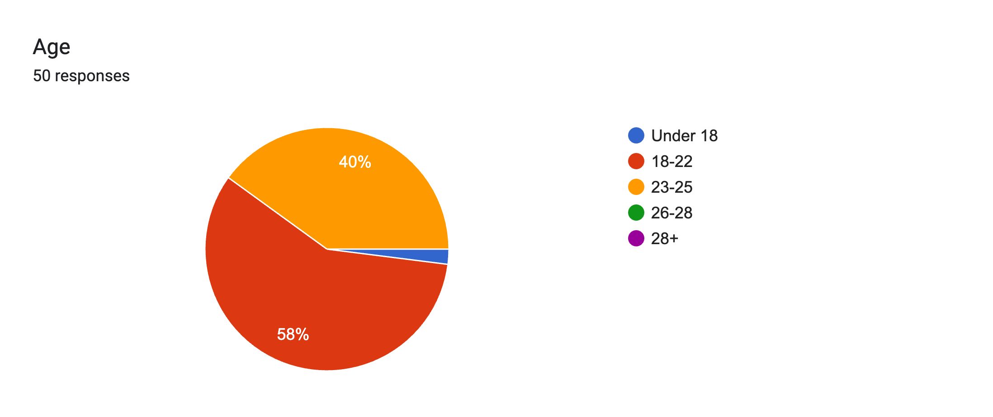

# **Figure 1:** Participants and their age

The percentage of the age of the participants were shown in figure 1. Most of the participants of this survey have ages between 18-22 and they constitute about 58% of Fig. 1. The second-largest group of participants has an age between 23-25 and they cover about 40%.

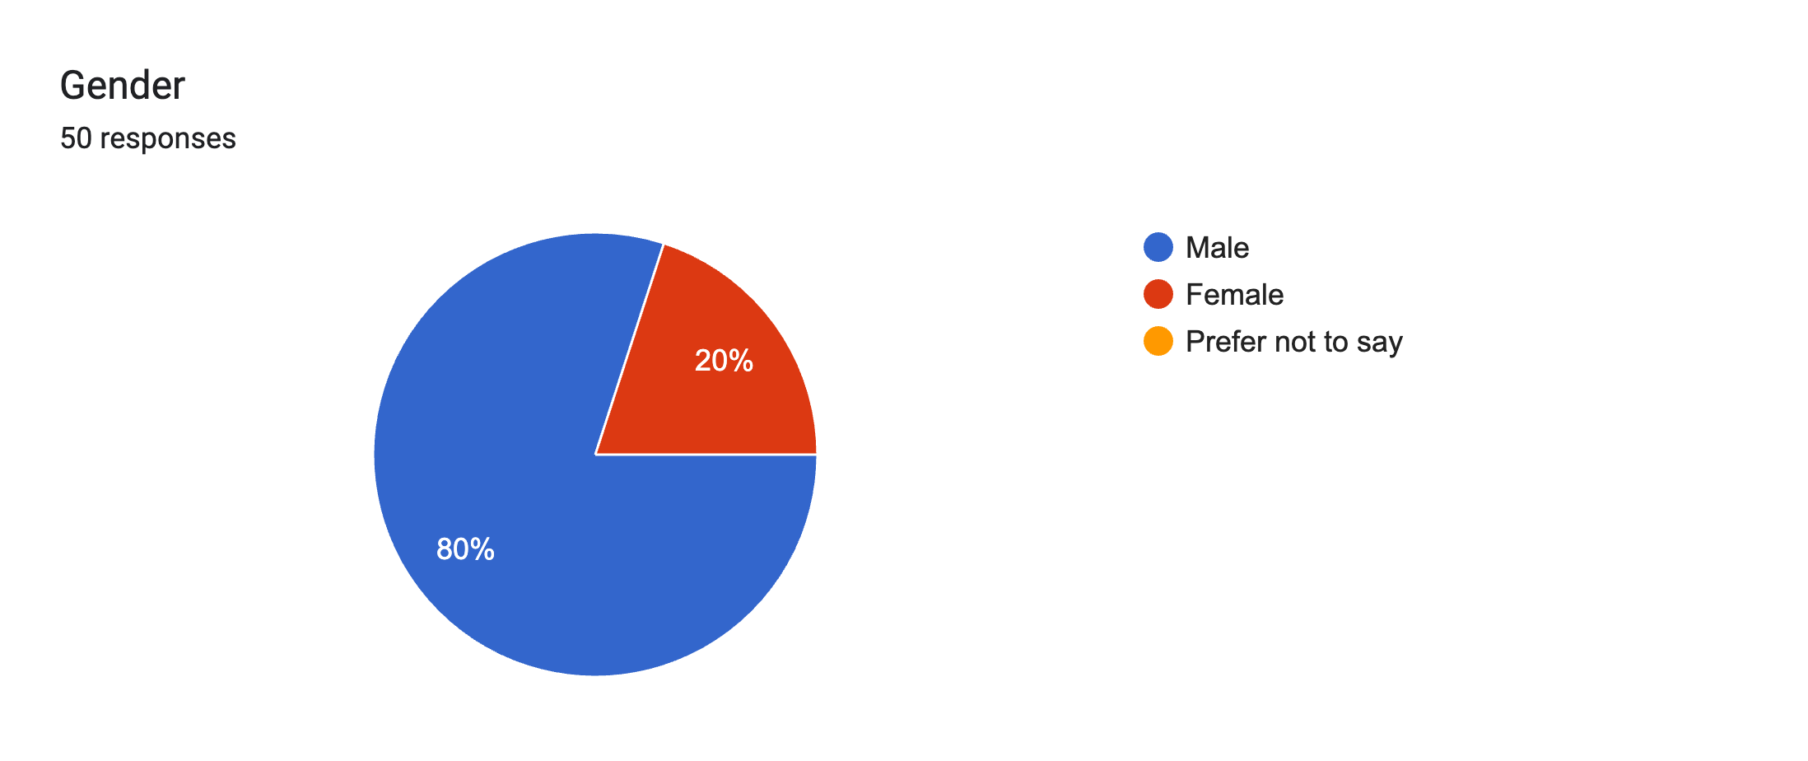

# Figure 2: Participants and their gender

The gender distribution of the survey participants was shown in Fig 2. The data indicates that approximately 80% of the participants identified as male, while 20% of the participants identified as female.

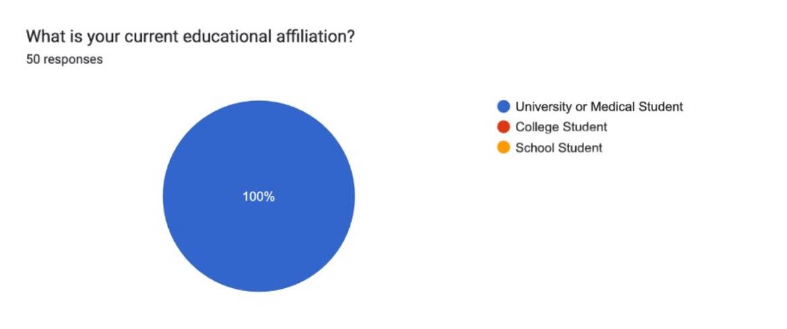

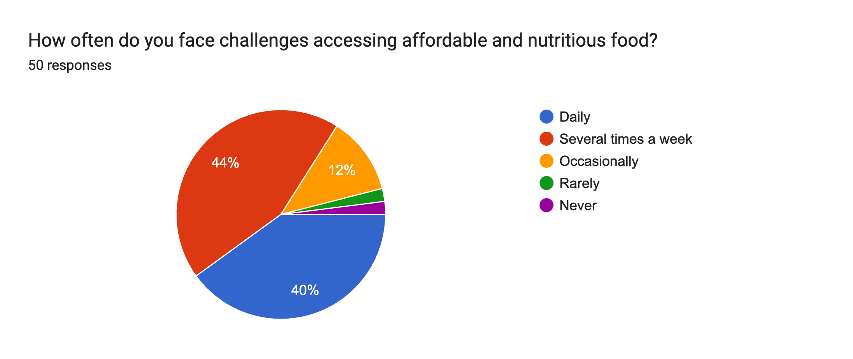

**Figure 4: Facing challenges accessing affordable and nutritious food**

Fig 3 revealed that most of the participants faced challenges several times a week and the percentage was 44%, 2nd largest group of participants faced challenges daily with the percentage of 40% and 12% of the participants faced challenges occasionally.

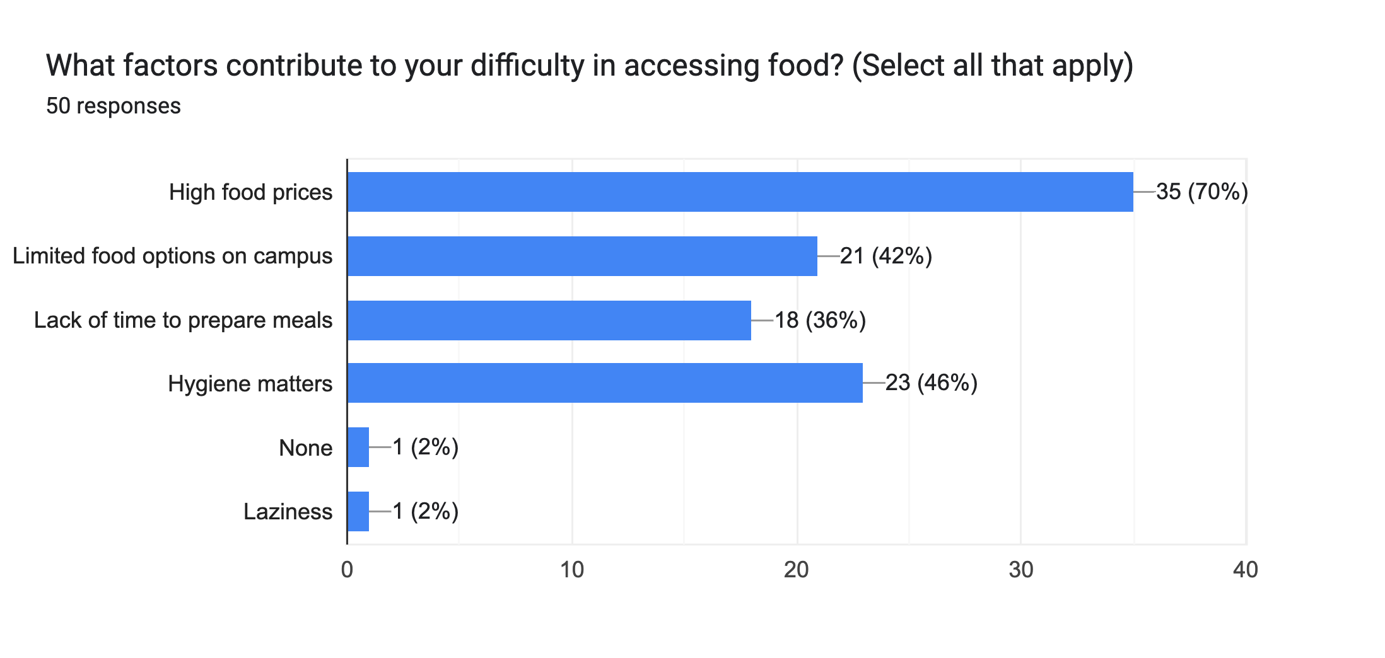

**Figure 5: Difficulty in accessing food**

It could be noticed from the fig 5 that high food prices contributes the most for difficulty in accessing food and limited food options on campus, Lack of time to prepare meals and Hygiene contributes almost the same.

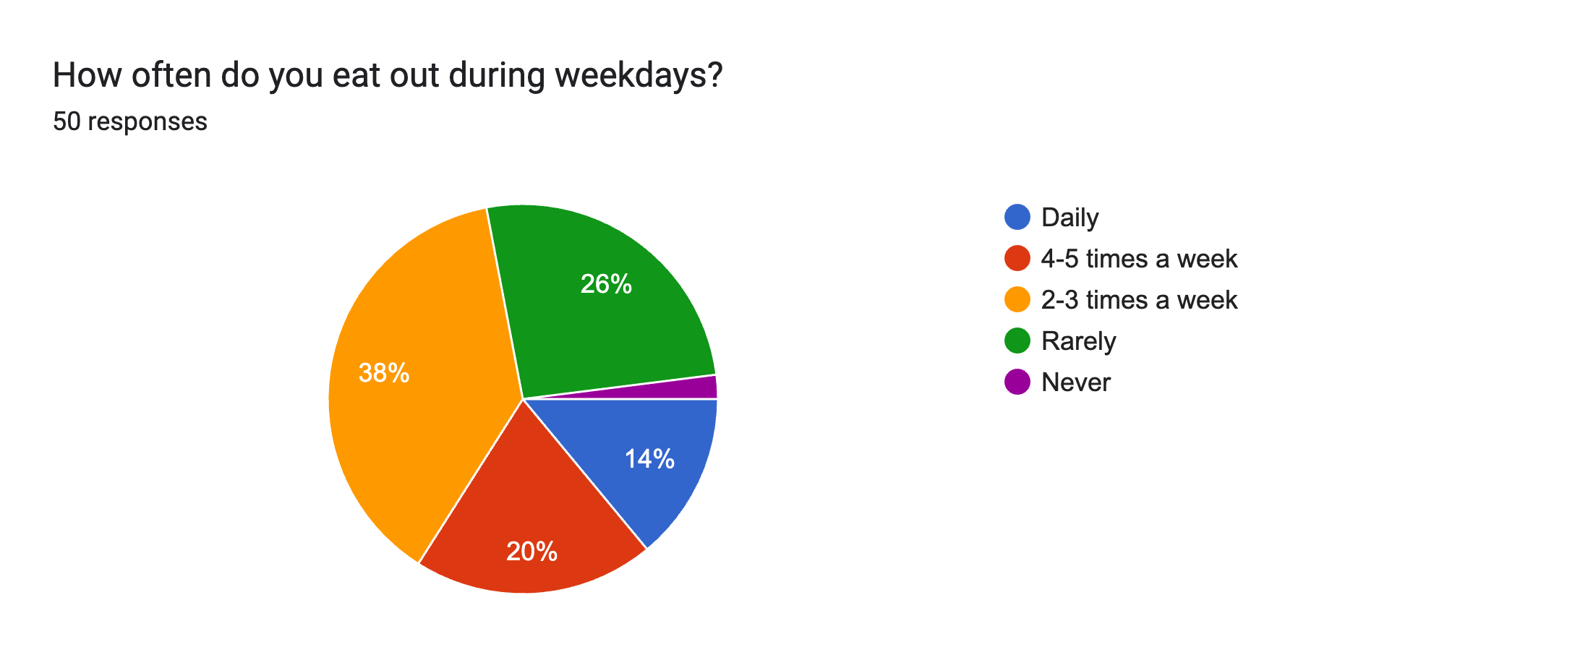

**Figure 6: Eating out during weekdays**

Fig 6 illustrates only 26% of the participants rarely eat out during weekdays and 72% of the participants often eat out during weekdays.

**Figure 3:** **Participants and their educational affiliation**

In Figure 3, it is demonstrated that 100% of the participants were university students.

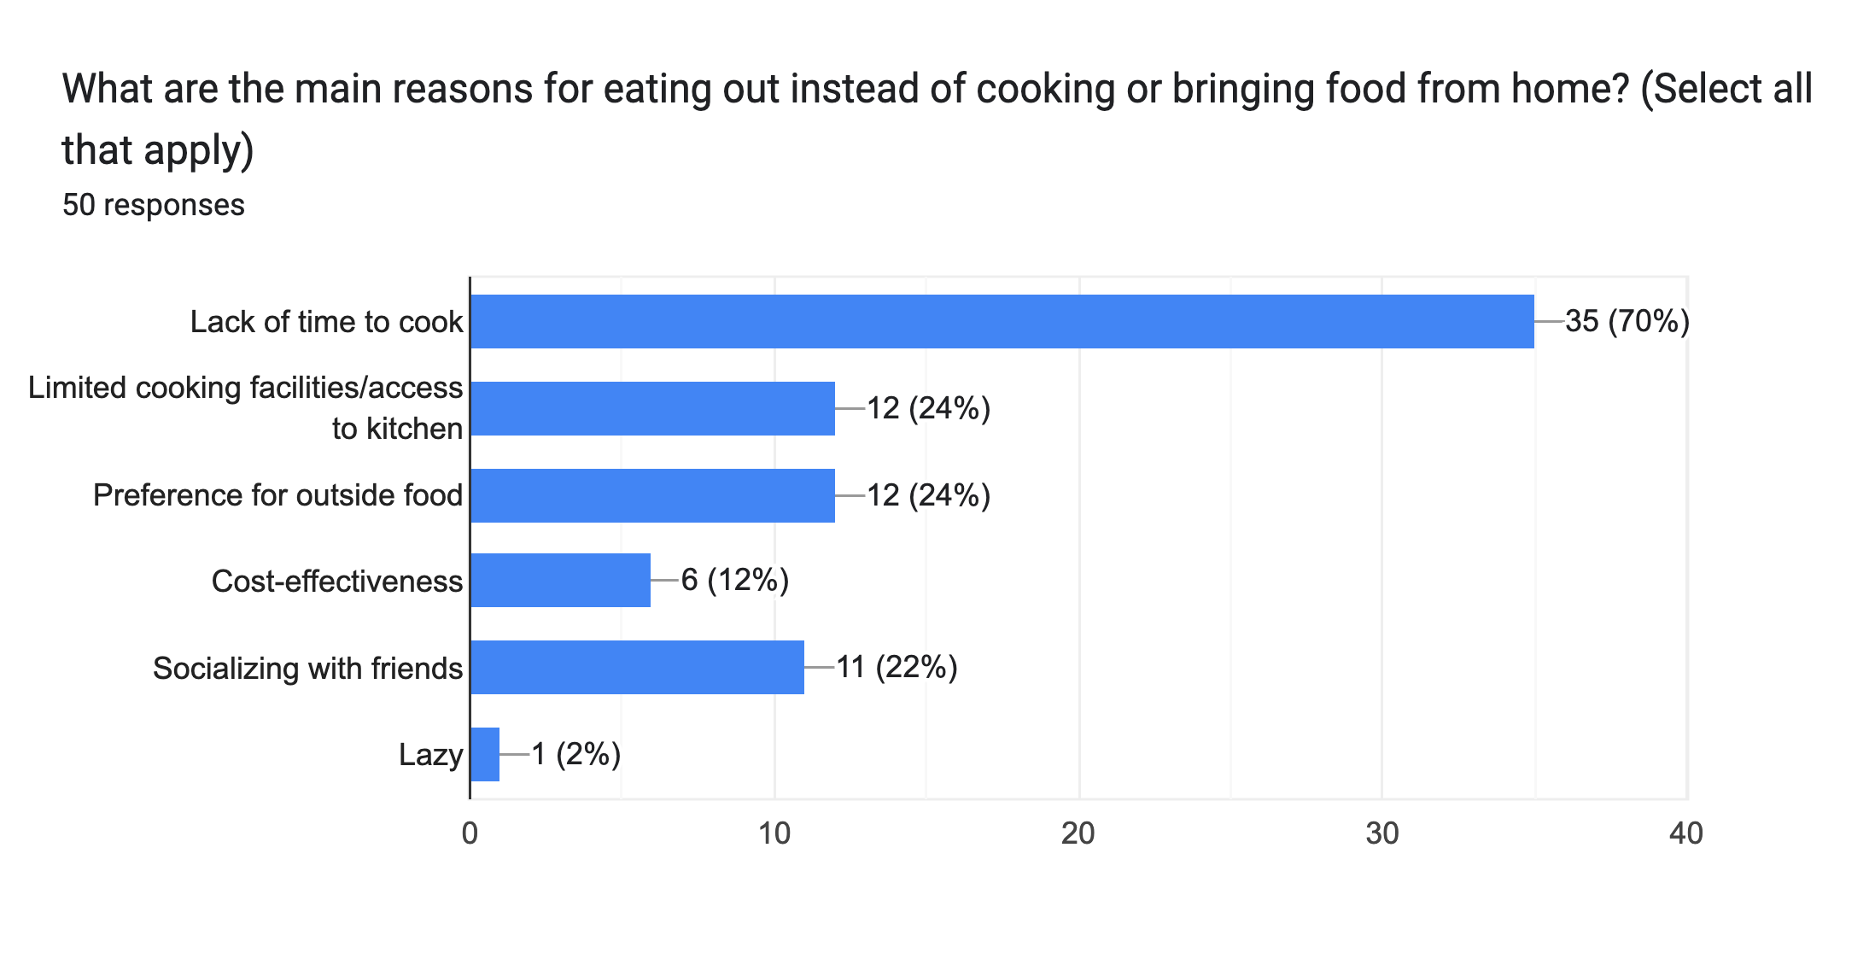

**Figure 7: Main reasons for eating out instead of cooking or bringing food home.**

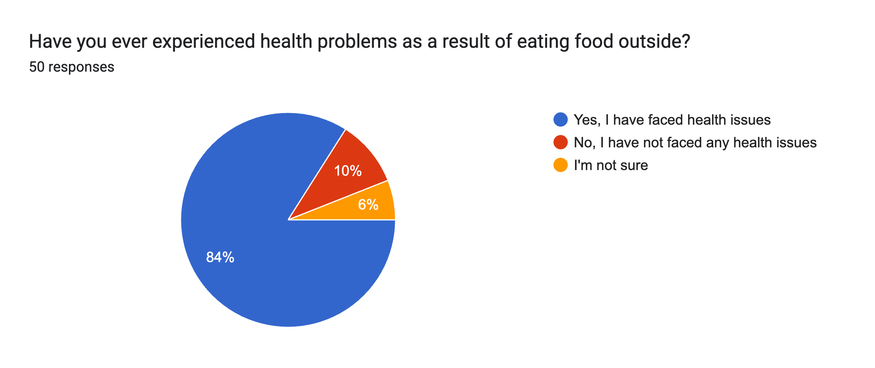

**Figure 8: Experiencing health problems for eating outside food.**

It could be shown in the fig 8 that a large number of participants faced health problems for eating outside food and the percentage is 84% and 6% of them were unsure.

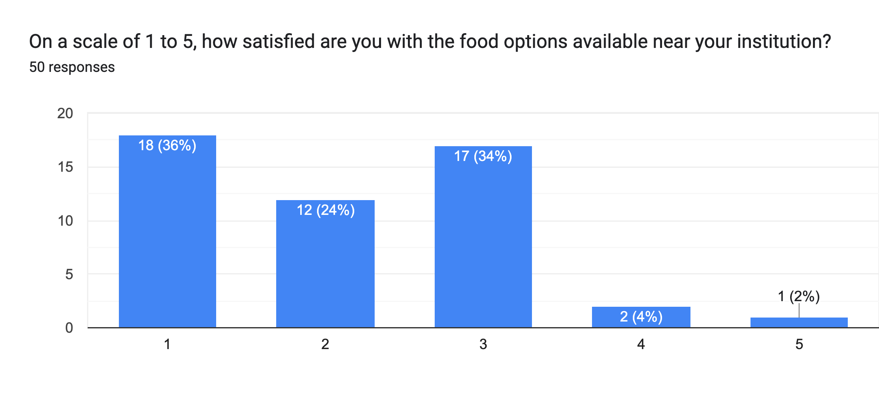

**Figure 9: How satisfied participants are with the food options available near their institution.**

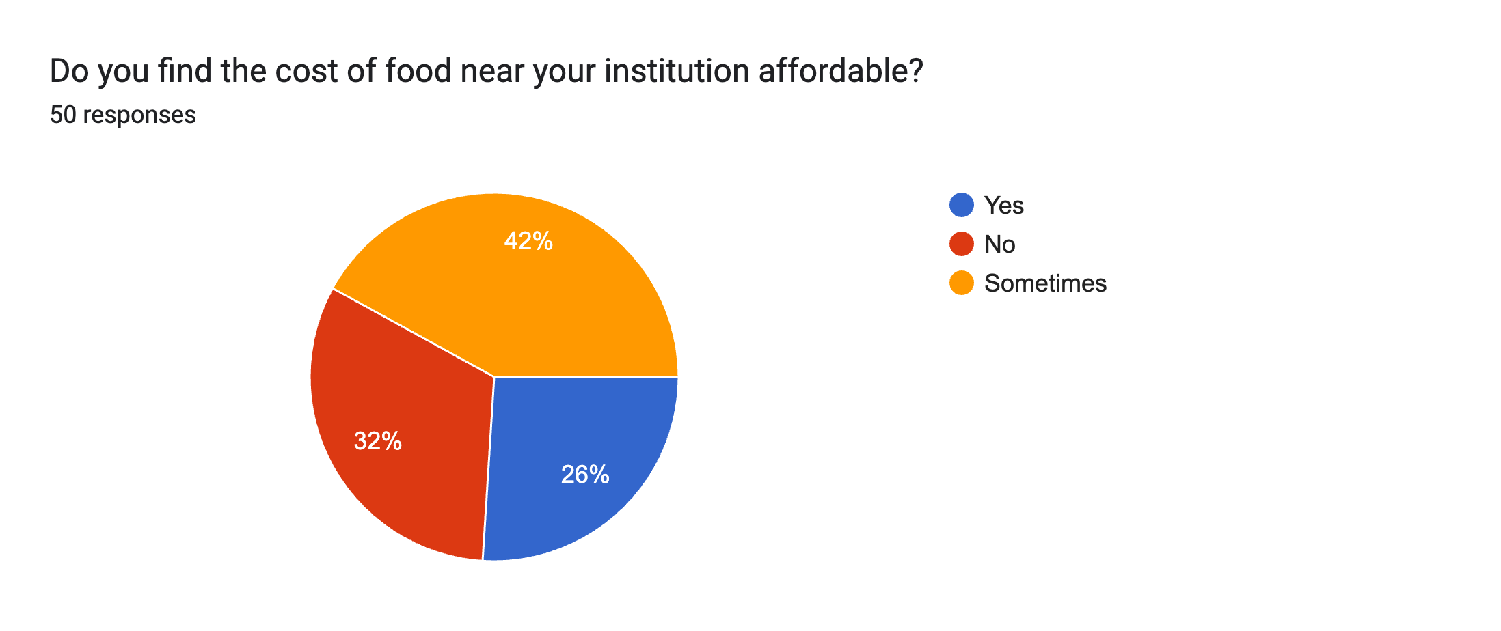

**Figure 10: Affordability of food near participants institution.**

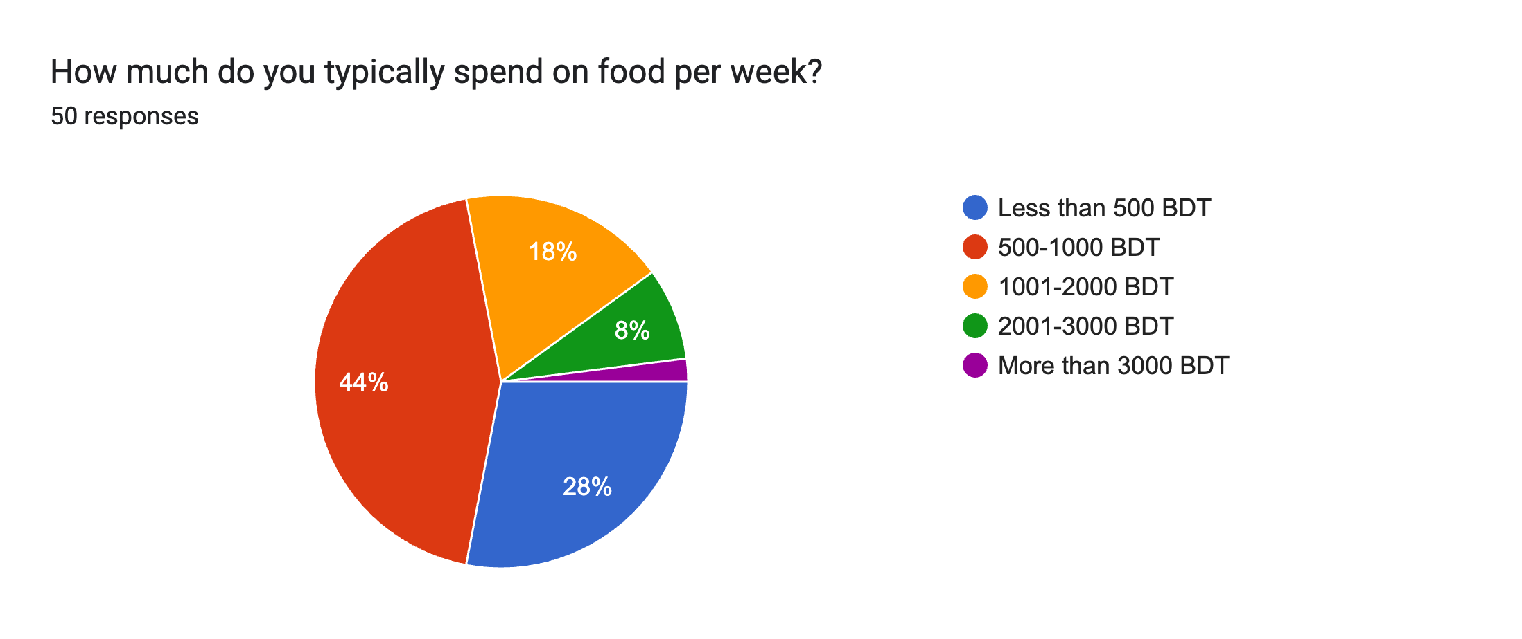

**Figure 11: How much typically participants spend on food per week.**

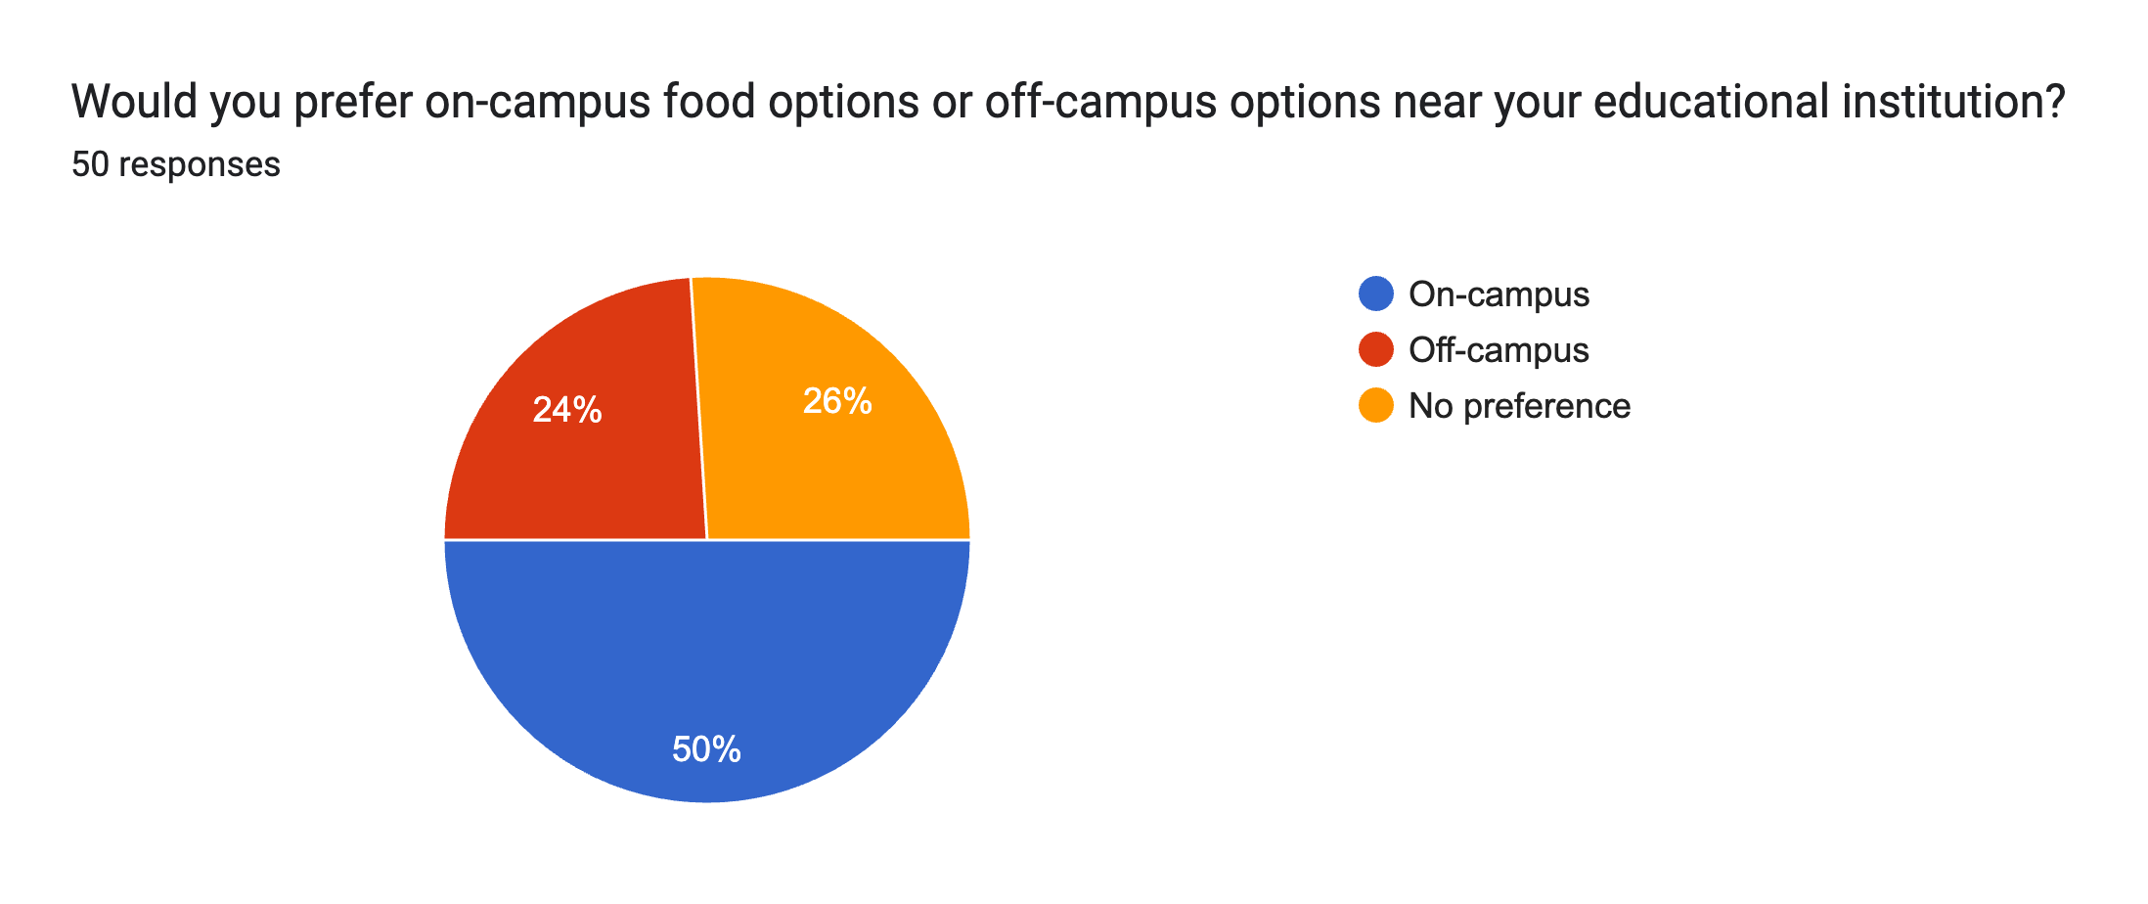

**Figure 12: Preference of on-campus or off-campus food.**

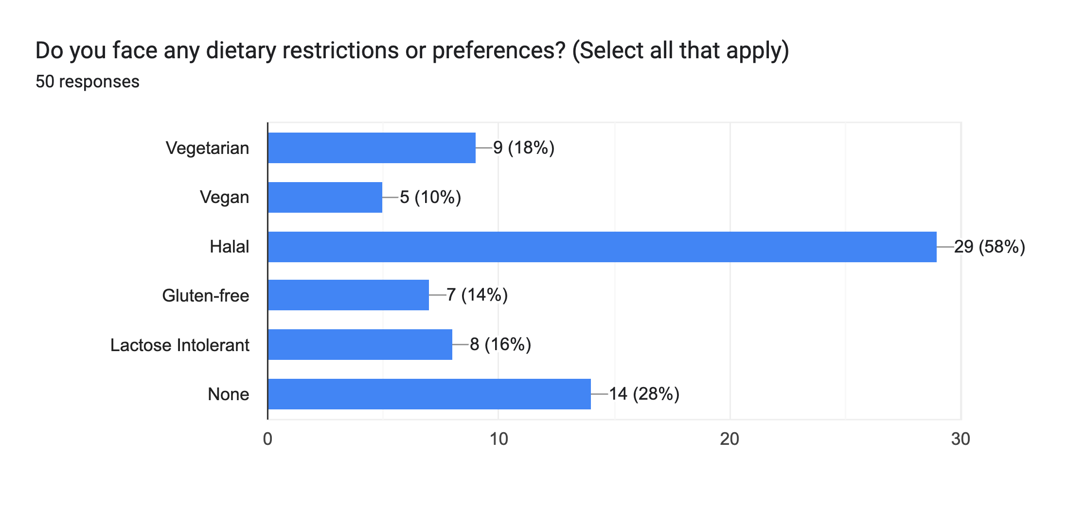

**Figure 13: Dietary restrictions.**

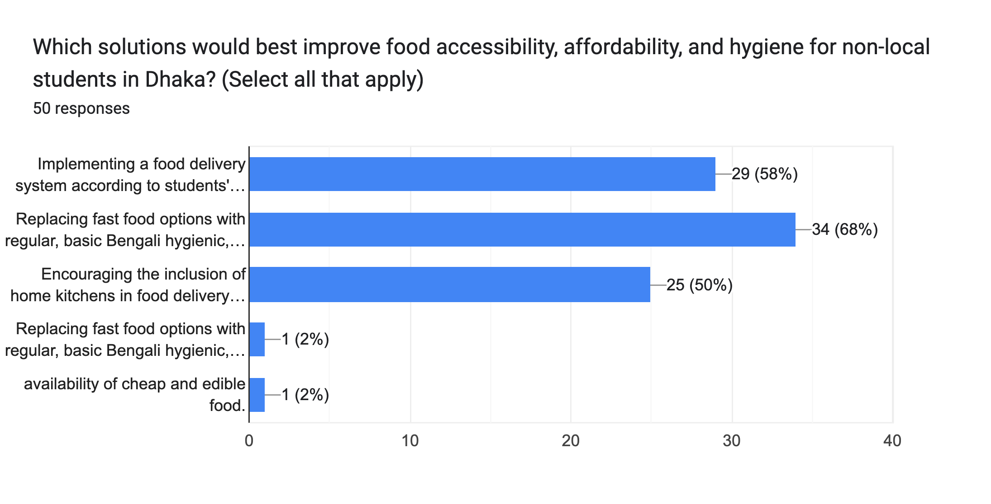

**Figure 14: Solutions for improving food accessibility, affordability and hygiene.**

***B. Discussion***

From the data in the result section, it can be said that non-local university students in Dhaka faced significant challenges in accessing affordable and nutritious food. Most participants were young (18-22). High food prices and limited campus options posed major hurdles, leading many students to rely on eating out, despite health concerns. Most of the students were not satisfied with the food accessibility. The results clearly indicate that we need to improve food options near institutions, implement a food delivery system and replace fast food options with regular, basic Bengali hygienic, and affordable food in campus cafeterias to help students progress academically and maintain their well-being.

IV. CONCLUSION

In conclusion, this study investigated the challenges faced by non-local students in Dhaka regarding food accessibility. The survey results revealed that a significant portion of students (84%) struggle to find affordable and nutritious meals. The heavy reliance on eating out (72%) often leads to health issues. Students expressed a clear need for improved food options near their institutions, with a preference for affordable, healthy, and hygienic Bengali foods. Based on these findings, the proposed technological solution of a mobile application or online platform that connects students with affordable meal options or delivery services seems highly relevant. Alongside replacing fast food options with regular, basic Bengali hygienic, and affordable food in campus cafeterias could significantly improve food security for non-local students in Dhaka

***A. Limitation***

The research's findings, despite their valuable insights, have limitations due to the small sample size and the focus on university students in Bangladesh, suggesting future research should involve larger-scale studies.

***B. Suggestions***

This study suggests a multi-step approach to improve food access for Dhaka's non-local students. A mobile app could connect them with affordable, healthy Bengali meals delivered by local restaurants. Partnering with universities to expand subsidized canteens with nutritious food would also help. Raising awareness of existing food banks and promoting healthier options from nearby vendors could improve their situation. Finally, replacing campus fast food with basic Bengali meals would greatly benefit these students. These efforts combined could significantly improve their food security and well-being, allowing them to focus on their studies.

V. REFERENCES

[1] Rahman, M. M., Hossain, M. Z., & Rahman, M. S. (2020). Food Accessibility Challenges Faced by Non-local University Students in Dhaka: A Qualitative Study. Journal of Health, Nutrition and Population, 38(1), 23-36.

[2] Islam, S., Haque, M. A., & Khan, M. S. (2019). Assessing the Impact of Food Insecurity on Academic Performance among Non-local University Students: Evidence from Dhaka, Bangladesh. Journal of Education and Social Sciences, 11(2), 45-58.

[3] Ahmed, S., & Mahmud, A. S. (2021). Leveraging Technology to Enhance Food Accessibility for University Students in Urban Settings: A Case Study of Dhaka. International Journal of Information Technology and Management, 25(3), 187-202.

VI. ACKNOWLEDGEMENT

We express our gratitude to our course teacher for his invaluable guidance and support throughout their research journey, as well as to everyone who participated in the survey, for their invaluable contributions to shaping their ideas and refining our research.

VII. APPENDIX

